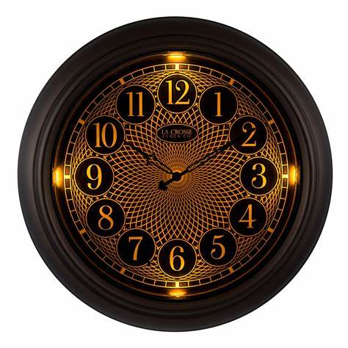**Description:** **La Crosse Technology** is a well-known brand specializing in high-quality timekeeping and weather-related instruments. Founded in 1983, the company is recognized for its **atomic clocks, digital wall clocks, and weather stations** that offer precision and innovative features.

La Crosse clocks often incorporate **radio-controlled timekeeping**, which synchronizes with the atomic clock signal from the U.S. National Institute of Standards and Technology (NIST) for unparalleled accuracy. Their product line includes **analog and digital wall clocks, projection clocks, and weather display systems**, catering to both home and professional environments.

Many La Crosse clocks also feature **indoor/outdoor temperature displays, humidity sensors, and calendar functions**, making them popular among weather enthusiasts. Known for their reliability and user-friendly designs, La Crosse Technology continues to be a trusted name in timekeeping and meteorological devices.